**1.1 Identify various java IDES and identify differences between them.**

Java IDE (Integrated Development Environment) is a software application that enables users to write and debug Java programs more easily. Most IDEs have features such as syntax highlighting and code completion that helps users to code more easily. Usually, Java IDEs include a code editor, a compiler, a debugger, and an interpreter that the developer may access via a single graphical user interface. Java IDEs also provide language-specific elements such as Maven, Ant building tools, Junit, and TestNG for testing.

**Best Java IDEs**

* Eclipse
* NetBeans
* IntelliJ IDEA
* BlueJ
* JCreator
* JDeveloper
* MyEclipse
* Greenfoot
* DrJava
* Xcode
* Codenvy

**Eclipse**

It is a Java-based open-source platform that enables us to create highly customized IDEs from Eclipse member's plug-in components. This platform is also suitable for beginners to create user-friendly and more sophisticated applications. It contains many plugins that enable developers to develop and test code written in different languages.

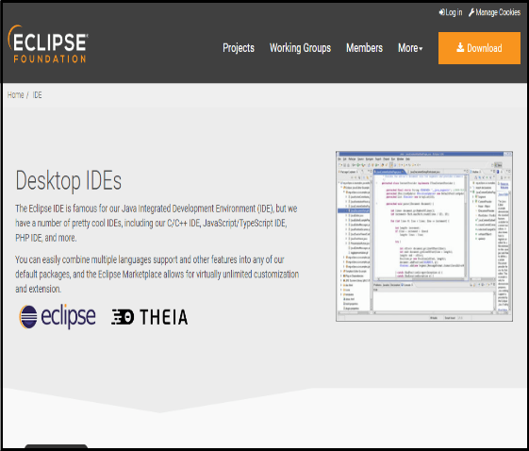

**NetBeans**

NetBeans is a Java-based IDE and basic application platform framework. Besides Java, JavaScript and JavaFX, NetBeans supports PHP, C/C++, Groovy, and HTML5 languages. It is a free and open-source Java IDE that enables Java developers to develop various applications using different module sets. Some of the following features of NetBeans are as follows:

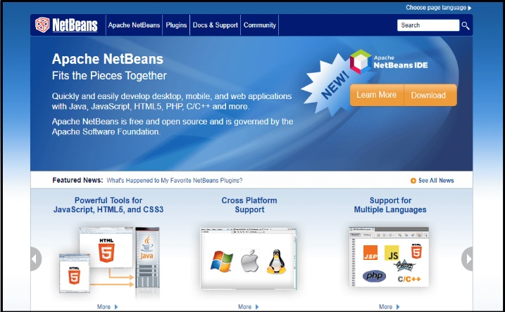

**IntelliJ IDEA**

It is a free and open-source commercial Java IDE. It has two versions that are a paid-up Ultimate edition and a free and open-source community edition. Some of the features of the IDEA IntelliJ are as follows:

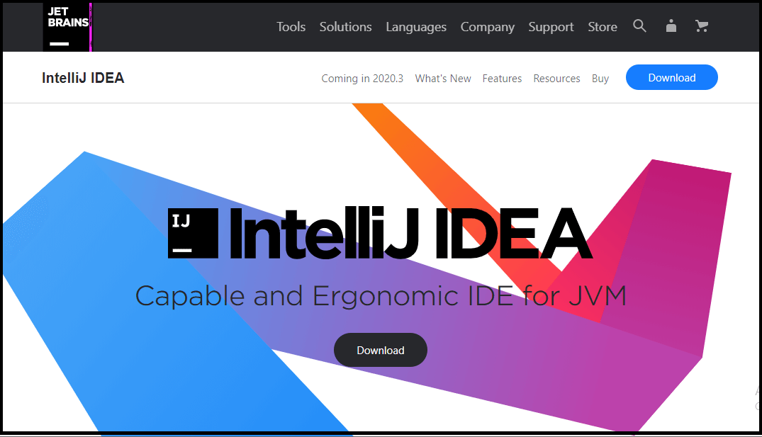

**BlueJ**

It is a Java IDE that is widely used by the world's Java programmers. However, it was mainly designed for educational purposes, but also useful for software development. Some of BlueJ's features are as follows:

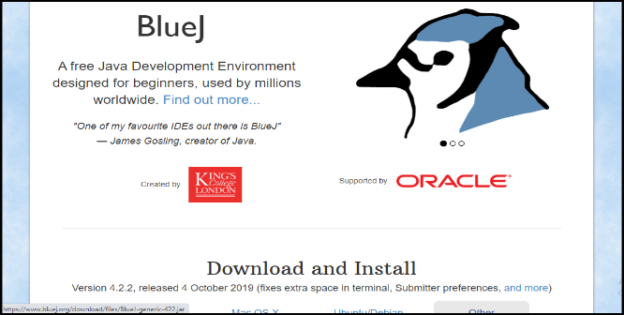

**JCreator**

It is another lightweight Java IDE developed by Xerox Software. It has a similar graphical interface to Microsoft's Visual Studio. It is available in three different versions: Lite Edition, Pro Edition and Life-Pro Edition. Unlike Java IDEs, which are developed using Java, JCreator is developed completely in C++. In addition, it does not require a JRE for Java code execution. The developer community believes that JCreator is quicker than most traditional Java IDEs for the unique purpose. On the other hand, it's small and easy, making it perfect for newbies starting with Java. The following are the features of JCreator IDE:

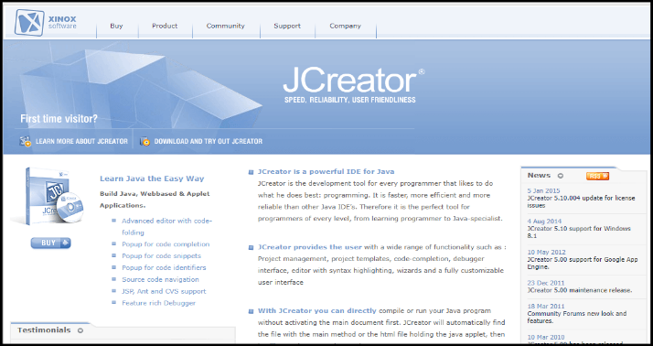

**JDeveloper**

JDeveloper is a free and open-source Java IDE supported by Oracle Corporation. It can be used to build applications in different languages other than Java, like PL/SQL, PHP, XML, HTML, JavaScript, SQL, etc. The following are the features of JDeveloper IDE:

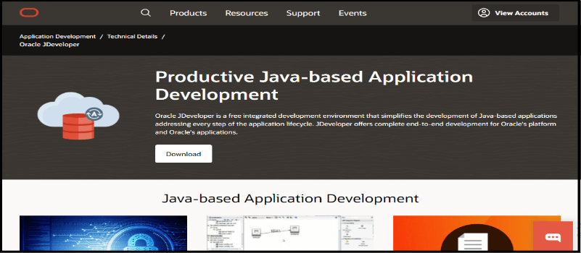

**MyEclipse**

It is a unique Java IDE built on top of the Eclipse platform that is created and maintained by Genuitec. Many tools and techniques available in MyEclipse could be used to develop Java apps and web development. It also offers support for JavaScript, HTML, Angular, and TypeScript and provides support for database connectors and application server connectors. It has five editions: the Professional Edition, the Regular Edition, the Blue Edition, the Spring Edition and the Bling Edition. Some of MyEclipse's features are as follows:

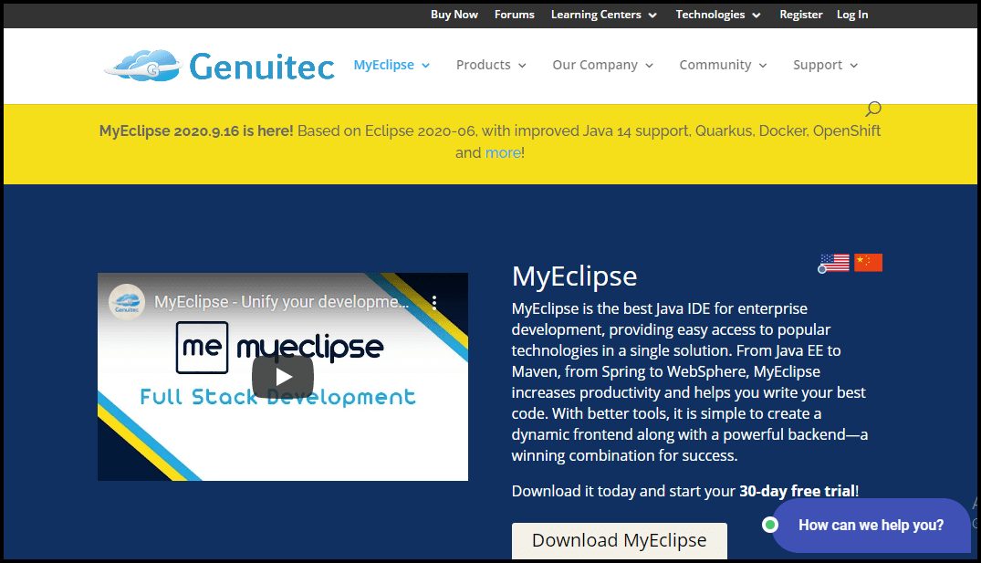

**Greenfoot**

It is an IDE that has been developed to provide high school and undergraduate education. Greenfoot is free and open-source software that is maintained with the help of Oracle. Some of Greenfoot's characteristics are as follows:

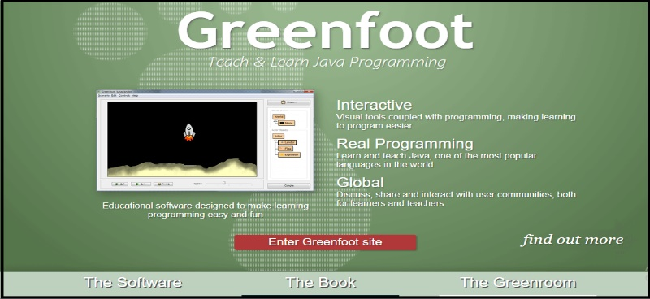

**DrJava**

It is a lightweight Java IDE organization maintained and operated by the JavaPLT Community at Rice University. It is mainly developed for beginners and students. However, it is not as advanced as different Java IDE's. It also has a remarkably culture-free interface. There are following features of DrJava as follows:

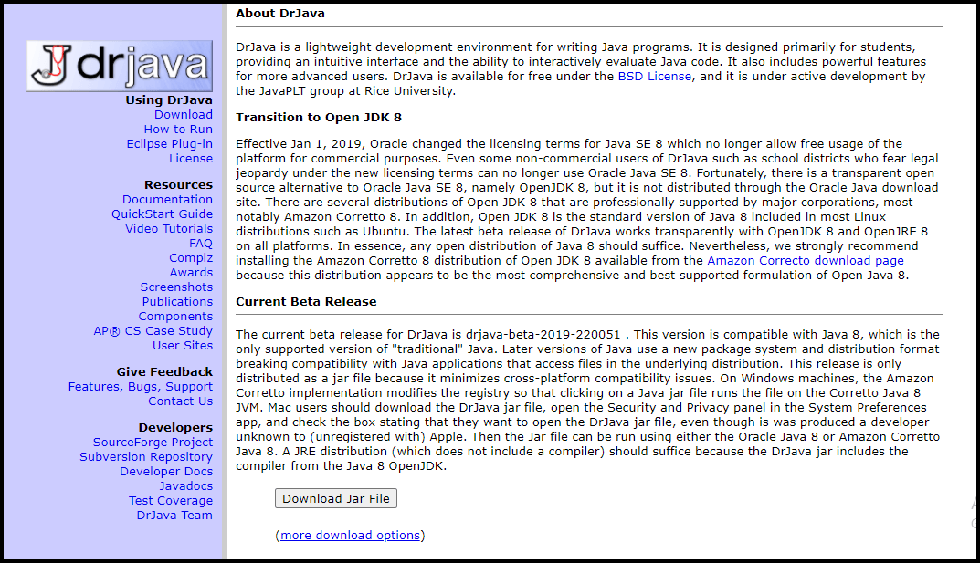

**Xcode**

It is a Java IDE developed by Apple Inc. for MacOS. It can be accessed free of charge. This IDE comes with several software development tools for the development of TVOS, MacOS, and iOS software and allows Java programming. Some of the main highlights of Xcode are the built-in debugger, GUI designer, and autocomplete profile. AppleScript, Objective-C, C, Objective-C++, C++, Ruby, Python, and Swift are provided by Xcode, in addition to Java. There are the following features of Xcode as follows:

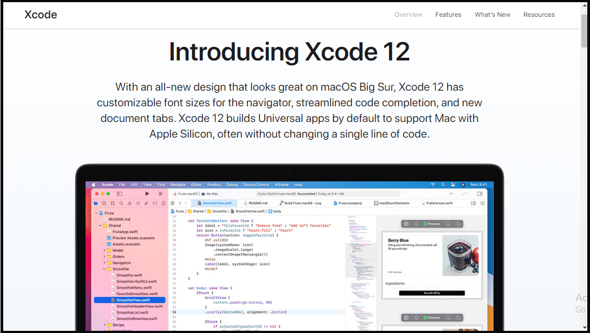

1.2 compare and contrast java with python.

Comparison between JAVA and Python

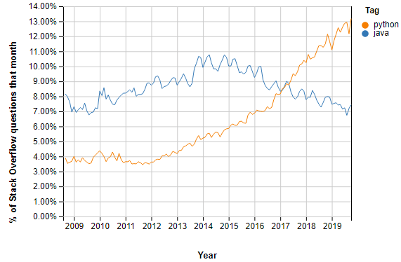

|  |  |  |
| --- | --- | --- |
| Parameter | Java | python |
| compilation | Java is a compiled language | Python is an interpreted language |
| Static or dynamic | Java is statically typed | Python is dynamically typed |
| Learning curve | Complex learning curve | Easy to learn and use |
| speed | Java program runs slowly compared to python | Python programs run faster than java |
| Read file | Java takes 10 lines of code to read from a file in java | Python only needs to 2 lines code |
| Backend frameworks | Spring, Blade | Django, Flash |
|  |  |  |
|  |  |  |
|  |  |  |
|  |  |  |
|  |  |  |
|  |  |  |
|  |  |  |
|  |  |  |
|  |  |  |
|  |  |  |
|  |  |  |